Jackson Warren

Jeremy Bergen

CSCI 370

12/6/21

Lab 14

Section 1:

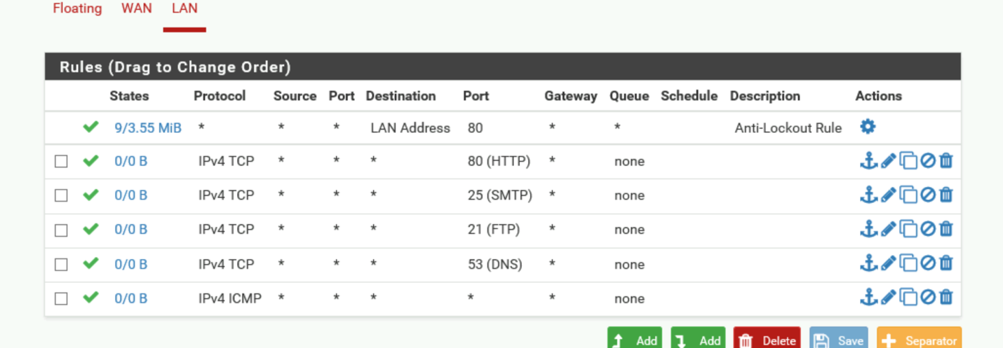

Section 2:

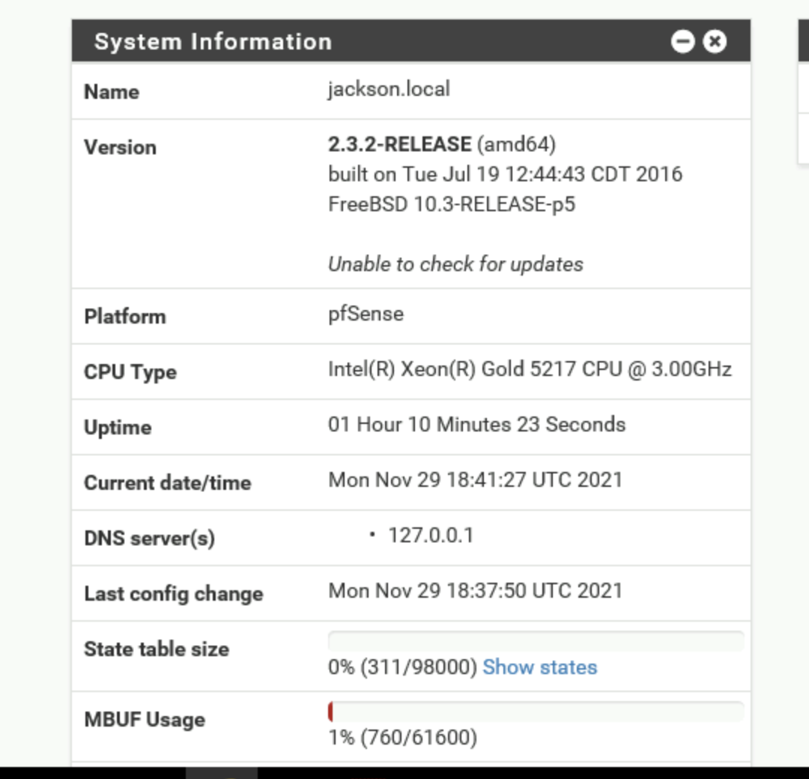

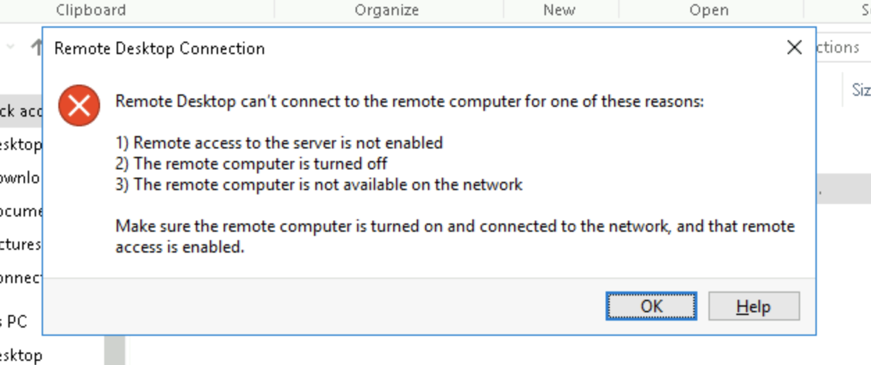

For the rest of this section, it is again not working to open TargetWindows01. Not quite sure why. I’ve tried changing wifi and restarting the session and everything but not cutting it.

Section 3:

Part 1: There’s a bunch of advantages and disadvantages. For this case, something like pfsense would be nice because you can specify the protections you want from your firewall and it isn’t so generalized such and Windows Firewall. Certain people could have more/less protections and it’s customizable so that you can protect exactly what you want.

Part 2: 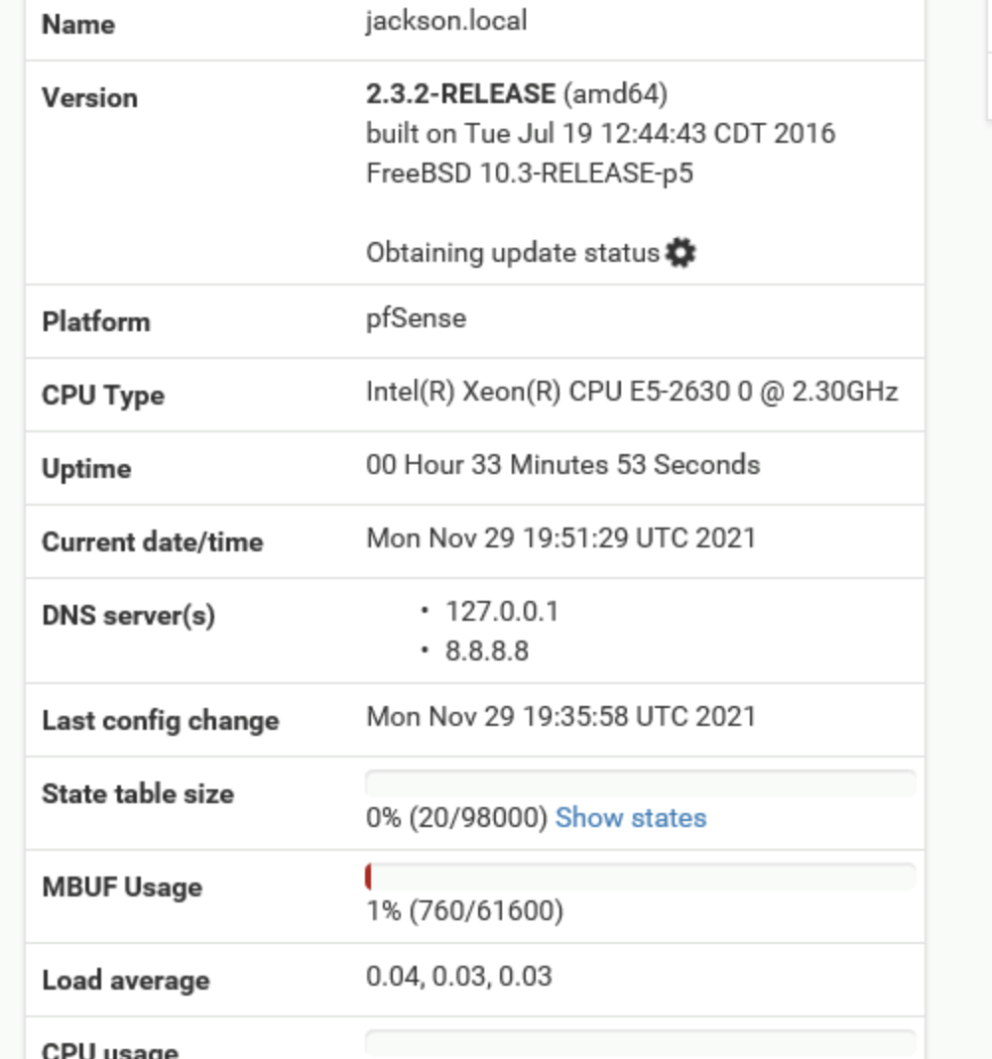

Part 3:

I can’t do this part either because I wasn’t able to create that RDP connection with TargetWindows01… Not sure what’s going on there but I haven’t had this issue before.